भारतमौसमविज्ञानविभाग |  | India Meteorological Department
Monday,09th June 2025 (19 Jyeshtha 1947 Saka)
Summary of observations recorded at 0830 hours IST: The Northern Limit of Monsoon continues to pass through 17.0°N/55°E, 17.5°N/60°E, 18°N/65°E, 18.5°N/70°E, Mumbai, Ahilyanagar, Adilabad, Bhawanipatna, Puri, Sandhead Island, 23.5°N/89.5°E, Balurghat, 30°N/85°E. The upper air cyclonic circulation over Haryana & neighbourhood lay over northwest Uttar Pradesh and neighbourhood which extended upto 1.5 km above m. s. l. of today morning. It then persisted over the same region. The trough ran from the cyclonic circulation over northwest Uttar Pradesh and neighbourhood to north Madhya Pradesh of today morning. It then ran from the cyclonic circulation over northwest Uttar Pradesh and neighbourhood to Telangana across Madhya Pradesh & Vidarbha at 0.9 km above m. s. l. The Western Disturbance as a trough in middle tropospheric westerlies with its axis at 5.8 km above m. s. l. ran roughly along Long. 58°E to the north of Lat. 25°N. persisted. The upper air cyclonic circulation over southeast & adjoining eastcentral Bay of Bengal persisted and seen between 5.8 & 7.6 km above m. s. l. A trough ran from north Tamil Nadu to south Maharashtra coast across Interior Karnataka between 3.1 & 4.5 km above m. s. l. An upper air cyclonic circulation lay over northwest Bay of Bengal and adjoining north coastal Odisha & south Gangetic West Bengal between 1.5 & 5.8 km above m. s. l. The upper air cyclonic circulation over north Chhattisgarh and adjoining east Madhya Pradesh at 1.5 km above m. s. l. of today morning. It then became less marked. The upper air cyclonic circulation over southeast Himachal Pradesh & adjoining Uttarakhand became less marked. The upper air cyclonic circulation over central Pakistan & neighbourhood became less marked. The trough in middle & upper tropospheric westerlies ran roughly along Long. 89°E to the north of Lat. 22°N. became less marked. The upper air cyclonic circulation over east Bangladesh & neighbourhood became less marked. The western disturbance as a cyclonic circulation over Ladakh & adjoining Kashmir became less marked.
Day temperatures were markedly above normal (> 5.1°C) at few places over Arunachal Pradesh; at isolated places over Assam & Meghalaya, west Uttar Pradesh, Haryana-Chandigarh-Delhi, Himachal Pradesh, Jammu-Kashmir-Ladakh-Gilgit-Baltistan-Muzaffarabad, east Madhya Pradesh and Tamil Nadu, Puducherry & Karaikal. appreciably above normal (3.1°C to 5.0°C) at many places over Punjab; at most places over west Rajasthan; at few places over Nagaland, Manipur, Mizoram & Tripura, sub Himalayan West Bengal & Sikkim, Bihar and east Uttar Pradesh; at isolated places over Gangetic West Bengal, Vidarbha, coastal Andhra Pradesh & Yanam and Kerala & Mahe. above normal (1.6°C to 3.0°C) at many places over Uttarakhand, east Rajasthan and Lakshadweep; at few places over west Madhya Pradesh and coastal Karnataka; at isolated places over Odisha, Saurashtra & Kutch, Chhattisgarh and Telangana. near normal (-1.5°C to 1.5°C) at many places over Madhya Maharashtra, north interior Karnataka and south interior Karnataka; at most places over Jharkhand, Gujarat region, Konkan & Goa and Rayalaseema; at few places over Marathwada; at isolated places over Andaman & Nicobar Islands. Yesterday, the highest maximum temperature of 47.4°C was reported at Sriganganagar (Rajasthan).
The Southwest Monsoon has been subdued over Arunachal Pradesh and Assam & Meghalaya.
Total 304 Station reported rainfall today. Total rainfall is 66.2 cm. Total 292 Station reported rainfall today whose normals are available. Total rainfall is 62.8 cm with normal station total is 167.9 cm.
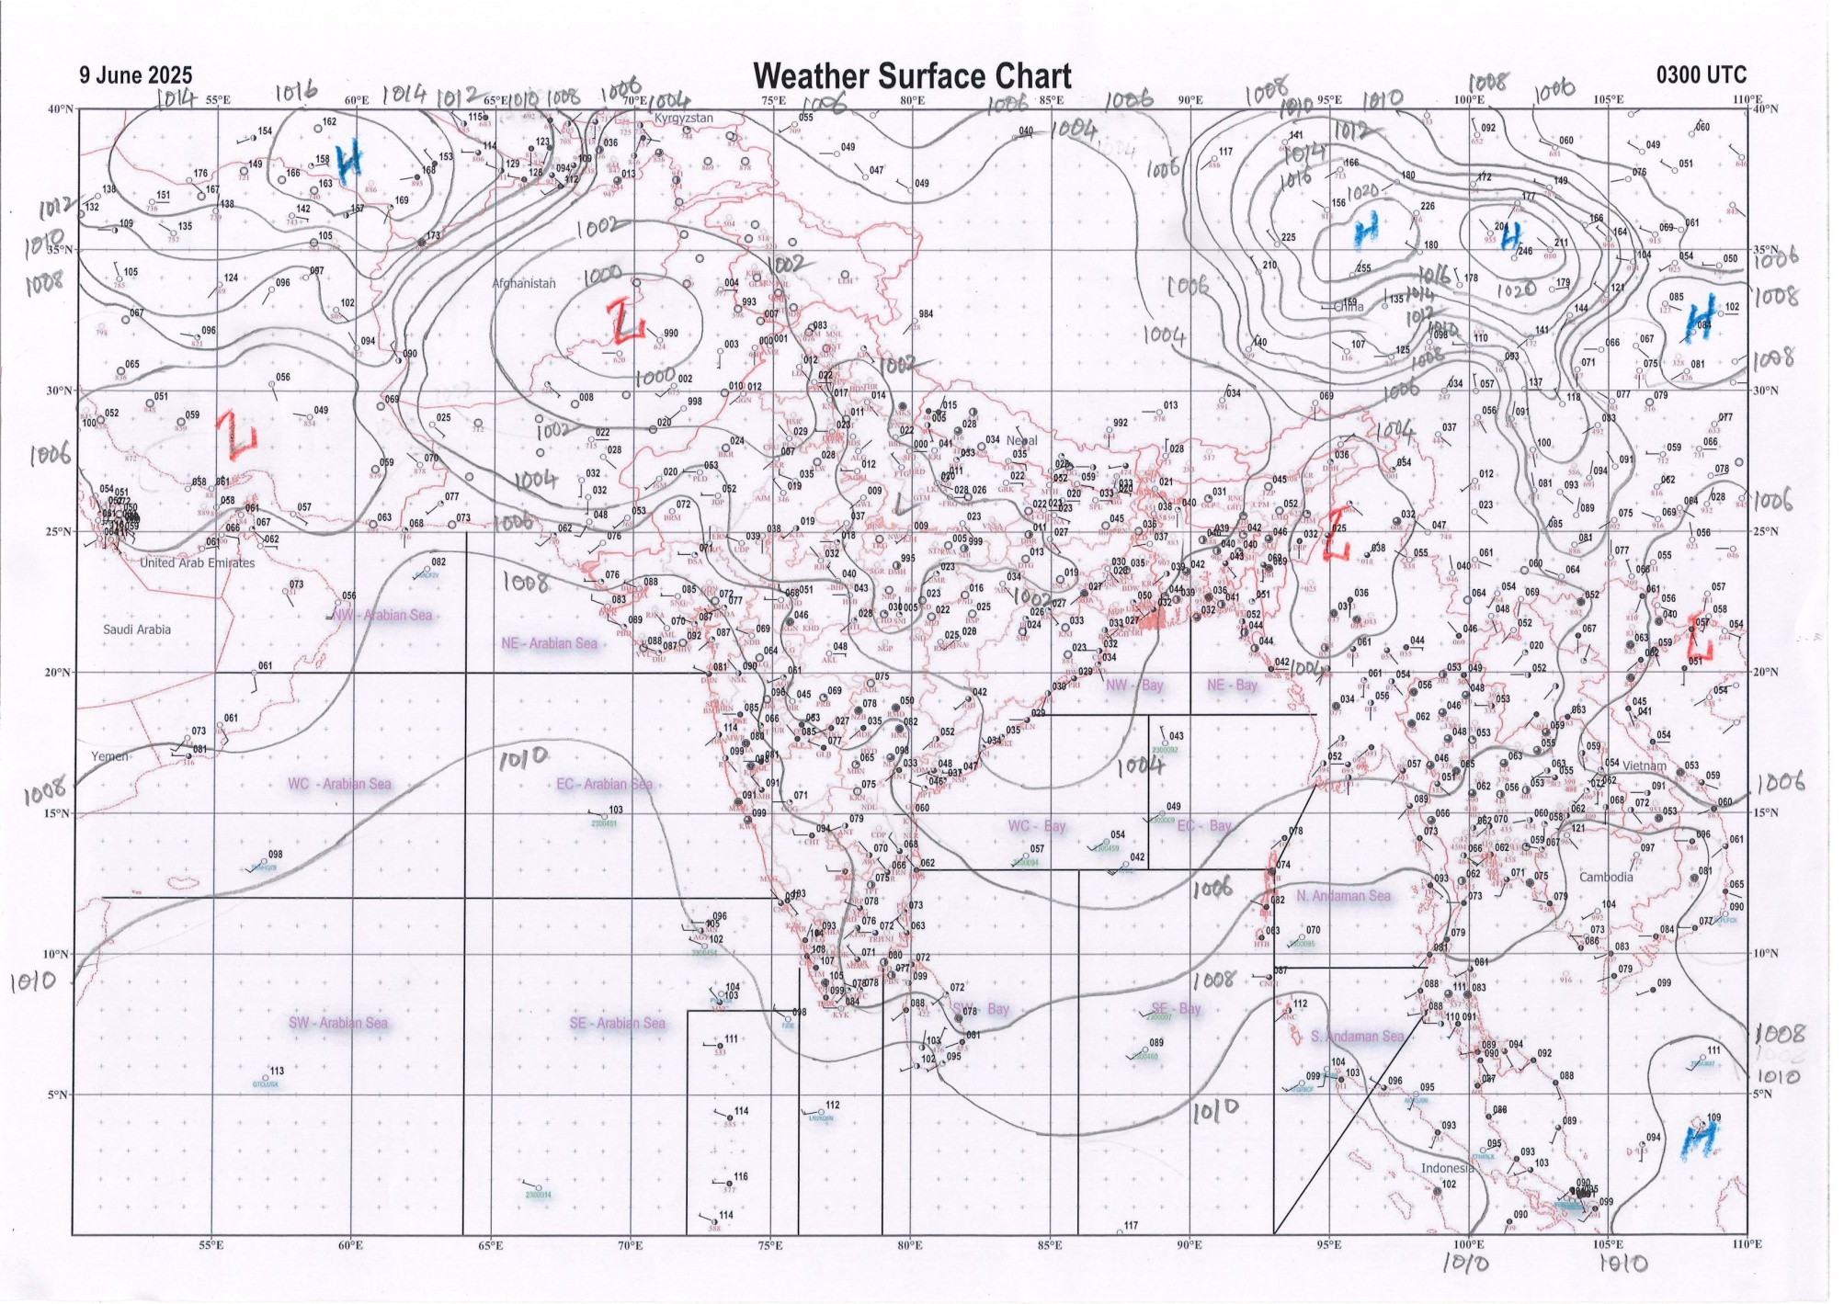 | 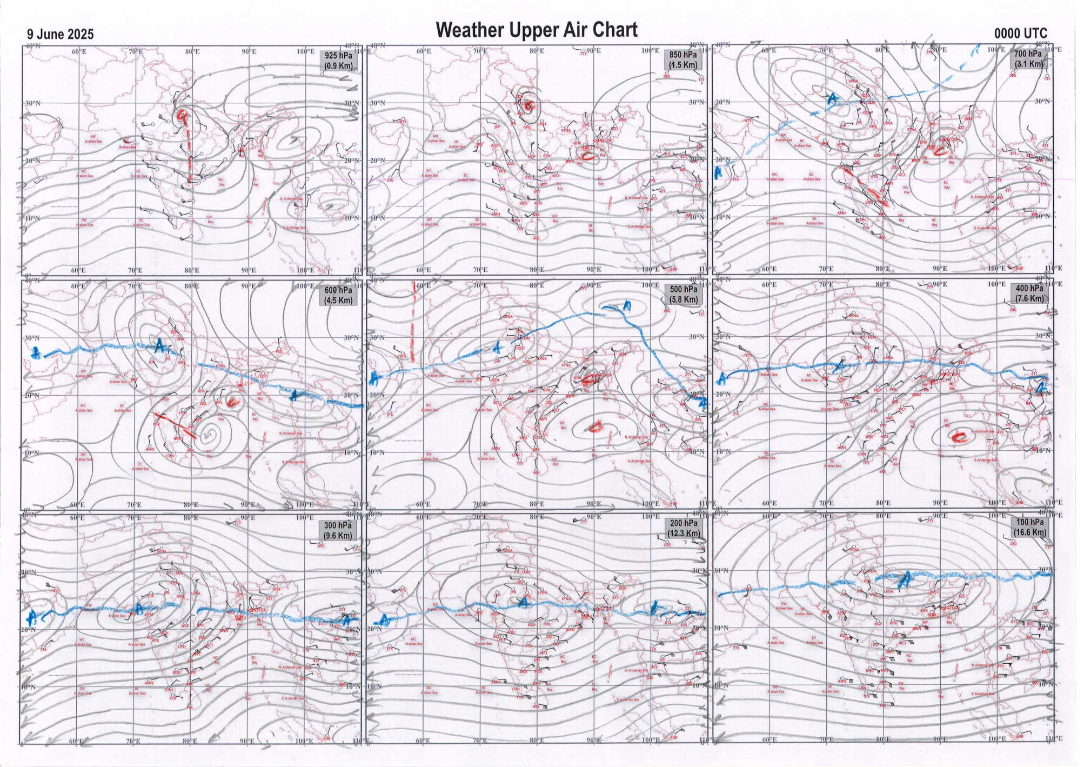
g.1. Analysed surface chart based on 03z observation | Fig.2. Analysed upper air chart based on 00z observation

Dr. Sudeep Kumar B.L.
Scientist ‘D’
CR & S Office, Pune  Issued at 1245 hrs. IST |  | Weather Forecasting Division  CR&S, Pune

Indian regions | Realised rainfall (chief amount in cm during past 24 hrs):
East | a few places: Nagaland-Manipur-Mizoram-Tripura  isolated places: Arunachal Pradesh◆, Assam & Meghalaya, Sub-Himalayan West Bengal & Sikkim, Gangetic West Bengal◆, Odisha and Jharkhand  dry weather: Bihar  Saiha AWS 6.1, Saiha 4.8, Kohima 2.7, Banspal 2.3, Baharagora 1.7, Srijangram ARG 1.6, Buxaduar 1.5, Dalgaon ARG, Jiti t.e. & Jhorigam 0.8 each, Barapani 0.6, Tawang AWS & Darjeeling 0.2 each, Anini AWS, Dum dum & Gumla bishnupur kvk AWS 0.1 each.
North | isolated places: Uttarakhand◆  dry weather: Uttar Pradesh, Haryana, Punjab, Himachal Pradesh, Jammu-Kashmir and Ladakh and Rajasthan  Sama 0.2.
Central | isolated places: Vidarbha and Chhattisgarh  dry weather: Madhya Pradesh  Bhamragad 2.8, Lohandiguda 1.5, Bastar 1.3, Kuhi 0.4, Rajnandgaon 0.1.
Peninsula | many places: coastal Karnataka+, north interior Karnataka+ and Kerala+  a few places: Konkan & Goa+, Marathwada++, Telangana+, Rayalaseema+ and south interior Karnataka++  isolated places: Gujarat Region◆, Saurashtra & Kutch, Madhya Maharashtra, coastal Andhra Pradesh and Tamil Nadu+  Lohara 13.8, Parasurampura 11.8, Tadwai 8.6, Kundapur 8.1, Sadasivanagar & Chalakudi 7.7 each, Panjim & Kakkeri 7.6 each, Mettur AWS 7.5, Uravakonda 7.1, Ratnagiri 7.0, Pennagaram 6.8, Idamalayar dam AWS 6.7, Mettur 6.4, Nilanga 6.0, Sutagatti mattikoppa 5.9, Settur 5.6, Yerragondapalem 4.9, Kochi c.i.a.l. 4.5, Vijayapura PTO & Agumbe emo 4.2 each, Nandyal 4.0, Bhagamandala 3.9, Kota 3.8, Tasgaon 3.2, Sankh 3.0, Awalegaon ARG 2.9, Dharashiv IMD parttime 2.3, Nizamabad 2.1, Mangaluru AP 1.9, Macherla 1.5, Sholapur 0.7, Lilia 0.5, Kaprada & Jangamaheswarapuram 0.2 each.
Islands | most places: Andaman & Nicobar  isolated places: Lakshadweep◆  Long island 3.6, Maya bandar 2.9, Port blair 2.6, Minicoy & Agathi 0.2 each.
Table 2. Forecast / warnings (distribution of rain / thundershowers) for 7 days (valid from time of origin upto 0830 hrs IST of next day)
Sr. No |  | Sub-division Name | Day 1 | Day 2 | Day 3 | Day 4 | Day 5 | Day 6 | Day 7 | Sr. No. | Sub-division Name | Day 1 | Day 2 | Day 3 | Day 4 | Day 5 | Day 6 | Day 7
 |  |  | 09 Jun | 10 Jun | 11 Jun | 12 Jun | 13 Jun | 14 Jun | 15 Jun |  |  | 09 Jun | 10 Jun | 11 Jun | 12 Jun | 13 Jun | 14 Jun | 15 Jun
 | 1 | Andaman Nicobar Islands | W  | W  | W +  | W +  | F | F | F | 19 | west Madhya Pradesh | D + | D + | I  + | I  | I  | S | S 
 | 2 | Arunachal Pradesh | I | S  | S  | F +  | F +  | F + | F+ | 20 | east Madhya Pradesh | D + | D + | I+ | I  | S  | S | S
 | 3 | Assam-Meghalaya | I  | I +  | S +  | S +  | F +  | F + | F+ | 21 | Gujarat region | I | I | I | I | I | I | I
 | 4 | Nagaland-Manipur-Mizoram-Tripura | S+ | F+ | S+ | S+ | S+ | S + | S+ | 22 | Saurashtra and Kutch | I | I | I | I | I | I | I
 | 5 | Sub Himalayan West Bengal/Sikkim | I | I | S  | F +  | F  | F + | F  | 23 | Konkan and Goa | S  | S | S | F++ | W # | W# | W#
 | 6 | Gangetic West Bengal | I + | I + | S  | F  | F  | F | F  | 24 | Madhya Maharashtra | I  | I  | I  | S +  | S ++  | F++ | F ++ 
 | 7 | Odisha | I  + | S +  | S  | S  | S  | S + | S  | 25 | Marathwada | I  | I  | S  | S + | I + | F+ | F+
 | 8 | Jharkhand | I | I  | S  | S  | S  | F | F  | 26 | Vidarbha | I  | I  | S  | F  | S  | I | I 
 | 9 | Bihar | I + | I + | S+ | F  | S  | S  | S  | 27 | Chhattisgarh | I  | I  | I  | S  | S  | S | S 
 | 10 | east Uttar Pradesh | D + | D + | I  | S  | I  | S  | S  | 28 | Coastal Andhra Pradesh and Yanam | I  + | I  + | F +  | F +  | S  | I | I 
 | 11 | west Uttar Pradesh | D + | D + | D + | I + | I  | I  | I  | 29 | Telangana | S  | S  | S  | F + | F  | F | S 
 | 12 | Uttarakhand | I | I | S  | F +  | F+ | F+ | F +  | 30 | Rayalaseema | S  | S +  | W+ | W+ | F+ | I | I+
 | 13 | Haryana,Chandigarh and Delhi | D + | D + | D + | D + | I  | I  | I  | 31 | Tamil Nadu, Puducherry and Karaikal | S + + | S +  | S+ | S+ | S++ | S ++ | S++
 | 14 | Punjab | D + | D + | D + | D + | D + | I  | I + | 32 | Coastal Karnataka | W +  | W +  | W ++ | W # | W # | W # | W #
 | 15 | Himachal Pradesh | D | D | D | D | I  | I  | I  | 33 | North interior Karnataka | W +  | F +  | F ++  | W ++  | W # | W ++ | W #
 | 16 | Jammu-Kashmir and Ladakh | D + | D + | D + | D + | I | I | I | 34 | South interior Karnataka | W+ | W+ | W++ | W # | W # | W ++ | W#
 | 17 | west Rajasthan | D + | D + | D + | D + | D + | D | D + | 35 | Kerala and Mahe | W +  | W +  | W +  | W ++  | W ++ | W ++ | W++
 | 18 | east Rajasthan | D + | D + | D + | D | I  | I  | I | 36 | Lakshadweep | W | W | W | W | W +  | W | W +
Legends: D = DryI = IsolatedS = ScatteredF = Fairly widespreadW = Widespread #= heavy to very heavy rain at a few places with extremely heavy rain at isolated places +++= heavy rain at a few places with very heavy rain at Isolated places ++= heavy to very heavy rainfall @=Isolated exceptionally heavy rainfall + = heavy rain ●/*= rain or snow ♦ = very light rain ≡=fog= thunderstorm with lightning =Squall / Gusty / gale / strong wind ­ =cold wave/cold day += heat wave/warm night/hot and humid weathe r=Duststorm =ground frost = Hail
Fig. 4: Districtwise warnings for five days for Maharashtra State
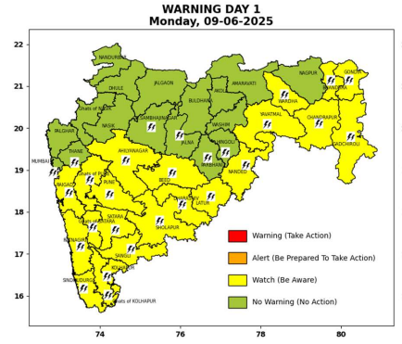 | 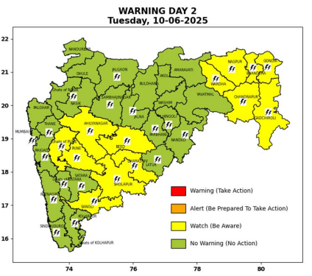 | 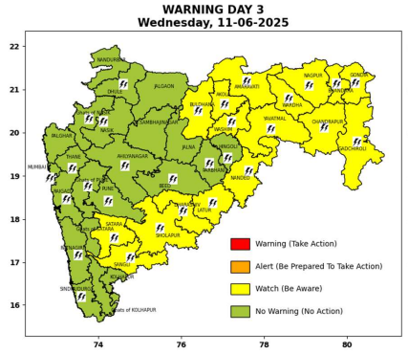 | 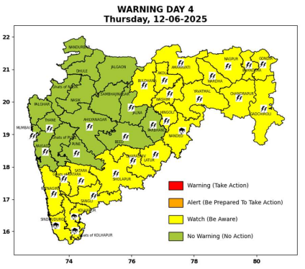 | 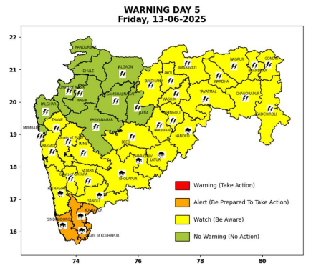

Pune, Lohegaon and Pashan observations at 0830 hrs. IST of Today
 | Temperature (°C) |  |  |  |  | Humidity (%) |  |  |  | Rainfall (mm)
 | Max.  past  24 hrs | Dep.  from  normal | Min.  past  24 hrs. | Dep.  from  normal | Dry  Bulb | At 0830 hrs. IST | Dep.  From  normal | At 1730  hrs. IST of y’day | Dep.  from  normal | Past  24 hrs. | Since  1st June | Dep.  from  normal
PNE | 32.2 | -2.1 | 23.8 | 0.4 | 26.2 | 80 | 7 | 68 | 10 | 0.0 | 38.1 | -11.6
PSN | 31.5 | - | 22.9 | - | 26.0 | 86 | - | 71 | - | 0.0 | 26.3 | -
LHG | 34.3 | 1.3 | 25.6 | 4.6 | 27.6 | 69 | -3 | 57 | 2 | 0.0 | 54.8 | 13.4

 |  |  |  |  |  |  | Local (Pune and neighbourhood) forecast
Max./Min. Temperature (°C) |  |  |  |  |  |  |  |  | Weather
Date | Pune | Pashan | Lohegaon | Chinchwad | Lavale | Magarpatta | NDA | Koregoan Park
09/06/25 | 32/23.8* | 31/22.9* | 34/25.9* | 31/24.5* | 29/23.5* | 33/25.6* | 31/23.3* | 31/25.5* | Partly cloudy sky becoming generally cloudy sky towards afternoon/evening. Thunderstorm with lightning, very light to light rain very likely.
10/06/25 | 33/24 | 32/23 | 35/26 | 32/25 | 30/23 | 34/26 | 33/23 | 32/25 | Partly cloudy sky becoming generally cloudy sky towards afternoon/evening. Thunderstorm with lightning, very light to light rain very likely.
11/06/25 | 33/24 | 32/23 | 35/26 | 32/25 | 30/23 | 34/26 | 33/23 | 32/25 | Partly cloudy sky becoming generally cloudy sky towards afternoon/evening. Thunderstorm with lightning, very light to light rain likely.
12/06/25 | 32/23 | 31/22 | 34/25 | 31/24 | 29/22 | 33/25 | 32/22 | 31/24 | Partly cloudy sky becoming generally cloudy sky towards afternoon/evening. Thunderstorm with lightning, light rain likely.
13/06/25 | 30/22 | 29/21 | 32/24 | 29/23 | 27/21 | 31/24 | 30/21 | 29/23 | Partly cloudy sky becoming generally cloudy sky towards afternoon/evening. Thunderstorm with lightning, light to moderate rain likely.
14/06/25 | 30/21 | 29/20 | 32/23 | 29/22 | 27/20 | 31/23 | 30/20 | 29/22 | Partly cloudy sky becoming generally cloudy sky towards afternoon/evening. Thunderstorm with lightning, light to moderate rain likely.
15/06/25 | 30/21 | 29/20 | 32/23 | 29/22 | 27/20 | 31/23 | 30/20 | 29/22 | Partly cloudy sky becoming generally cloudy sky towards afternoon/evening. Thunderstorm with lightning, light to moderate rain likely.
Rainfall Distribution |  |  | Rainfall Categories | Rainfall (mm) |  | Cloud condition |  |  |  | Rainfall Intensity |  | Range
Widespread (W) | 76-100% |  | Very Light rain | Trace to 2.4 mm |  | Mainly clear sky |  | 1-2 oktas |  | Light Spell |  | 1 cm/hr
 |  |  | Light rain | 2.5 to 15.5 mm |  | Partly cloudy sky |  | 3-4 oktas |  | Moderate Spell |  | 1-2 cm/hr
Fairly Widespread (FW) | 51 – 75% |  | Moderate rain | 15.6 to 64.4 mm |  | Generally cloudy sky |  | 5-7 oktas |  | Intense Spell |  | 2-3 cm/hr
Scattered (S) | 26 – 50% |  | Heavy rain | 64.5 to 115.5 mm |  | Overcast |  | 8 oktas |  | Very Intense Spell |  | 3-5 cm/hr
isolated (I) | 1 – 25% |  | Very heavy rain | 115.6 to 204.4 mm |  |  |  |  |  | Extremely Intense Spell |  | 5-10 cm/hr
D (D) | No Rain |  | Extremely heavy rain | ≥ 204.5 mm |  |  |  |  |  | Cloudburst |  | > 10 cm/hr
Probability Terms in %: |  |  | Heavy snow | 6.5 to 11.5 cms water equivalent of rain
unlikely | < 25 |  | Very heavy snow | 11.6 to 20.4 cms water equivalent of rain
likely | between 25 50
very likely | between 51 75
most likely | >75
* = realized temperature
Mumbai (Colaba) |  |  |  | Nagpur (AP)
Date 2025 | T max °C | T min °C | Weather | T max °C | T min °C | Weather
09/06 | 32 | 27 | Partly cloudy sky with one or two spells of rain or thundershowers. | 43 | 27 | Partly cloudy sky towards afternoon or evening.
10/06 | 33 | 27 | Partly cloudy sky with one or two spells of rain or thundershowers. | 43 | 28 | Rain or thundershowers accompanied with lightning & gusty winds(40-50kmph).
11/06 | 33 | 27 | Partly cloudy sky with one or two spells of rain or thundershowers. | 40 | 27 | Rain or thundershowers accompanied with lightning & gusty winds(50-60kmph).
12/06 | 32 | 27 | Partly cloudy sky with one or two spells of rain or thundershowers. | 39 | 26 | Rain or thundershowers accompanied with lightning & gusty winds(40-50kmph).
13/06 | 32 | 27 | Partly cloudy sky with one or two spells of rain or thundershowers. | 38 | 26 | Rain or thundershowers accompanied with lightning & gusty winds(40-50kmph).
14/06 | 32 | 25 | Heavy Rainfall. | 37 | 26 | Generally cloudy sky with possibility of rain or Thunderstorm.
15/06 | 32 | 25 | Heavy Rainfall. | 36 | 26 | Generally cloudy sky with possibility of rain or Thunderstorm.

